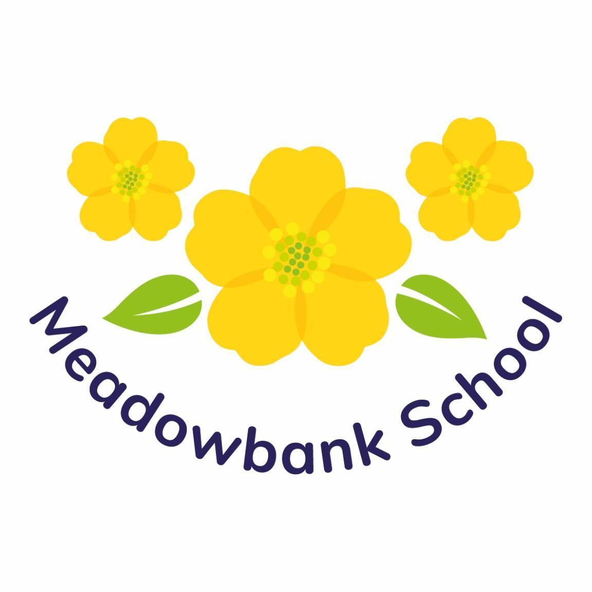

Governors Annual Report to Parents
2024-25

Meadowbank School
Colwill Road
Gabalfa
Cardiff
CF14 2QQ

Headteacher: | Mrs Claire Hardy
Chair of Governors: | Mr Mike Borley
Clerk to Governors: | Mrs Bethan Jones

 | A foreword from the  Chair of Governors


On behalf of the Governing Body, I am pleased to present our Governors Annual Report covering the academic year 2024-25. This report outlines the work, activities, and achievements of the school during this year.

I hope the first term of the school year has been a successful one with your children settling back into school well. I know this can be a challenge after a long summer break, but I know that our staff always look forward to welcoming our learners at the start of the year.

I am pleased to have been re-elected as Chair for this academic year. Although this can be a challenging role, it is also a rewarding one. I know that our role as a Governing Body is having a positive direct positive impact for the school. As a Governing Body, the positive impact for pupils is always at the forefront of any decision making.

The school has continued to carefully manage its finances through on-going budget monitoring. Special thanks must go to Mr Gareth Watts (Vice Chair of Governors & Chair of Finance Committee), Mrs Hardy & the School Office Manager for the careful and excellent monitoring of the school finances and resources.

As always, I am very grateful to my fellow Governors, who work hard to provide strategic direction for the school. As a reminder, the Governor role is entirely voluntary, and we are very lucky to have so many Governors who give up their own time for the good of the school and who regularly visit the school to gain first-hand knowledge. This year for the Governing Body was most exciting, as for the first time in it’s history, we expanded the membership to 17 members. All our newly appointed Governors had settled in well, and have been working collaboratively with Mrs Hardy, and alongside with our most experienced Governors as part of their professional development as Governors.

My special thanks must go to Mrs Hardy, the Senior Leadership Team, and all our valued staff at Meadowbank. Their continued strong, positive and valued commitment to supporting the school and pupils during this year has been inspiring and heart-warming to see.

I hope you enjoy reading this report to see the progress Meadowbank achieved during this year.

Best Wishes,



Mr Mike Borley
Chair of Governors
What do Governors do?

Governors work closely with the Headteacher to manage the school budget and premises, appoint staff, and help the school to set strategic priorities. The Governing Body also plays an important role in monitoring the school’s progress, helping to set targets to ensure the school continues to provide an excellent learning environment for all the children.

Governors also play an important role in ensuring the school has robust policies and procedures in place for safeguarding children, and that the school is a safe place to work, learn and play.

The Governing Body is a team made up of Parents (nominated and elected by parents of the school), Teaching and Staff representatives, Governors appointed by the Local Authority and Community Governors (co-opted because they have links, skills or expertise that will benefit the school). The Governing Body of Meadowbank School brings together individuals with a diverse range of skills and experiences to support the school in achieving its aims and objectives.

The full Governing Body meets four times a year, with sub-committee meetings prior to full Governing Body meetings. That ensures that sub-committees are able to update the full Governing Body with feedback on their own particular areas of responsibility.

Governors share a common goal to see the school achieve excellence, providing the children with the very best school life along with excellent facilities to support pupil development and growth.

Our Governing Body

The Governing Body membership for 2024-25 was as follows:

CHAIR OF GOVERNORS  Mr Mike Borkey  VICE CHAIR OF GOVERNORS  Mr Gareth Watts  HEADTEACHER  Mrs Claire Hardy  LOCAL AUTHORITY GOVERNORS  (Appointed by the Local Authority)  Mr Mike Borley  Dr. Laura Hrastelj  Mr Gareth Newell  Prof. Elspeth Webb  COMMUNITY GOVERNORS  Mr Chris Hancock  Mrs Anne Taplin  Mr Harry Verlander  Mr Gareth Watts | PARENT GOVERNORS  (Appointed following Parent Vote)  Mrs Zolaikha Khan  Mrs Samirah Phillips  Mrs Bethany Rees  Dr Yasir Syed  Mrs Rebecca Wright-Williams  TEACHER GOVERNORS  Mr Paul Roderick  Mr Daniel Williams-Jones  STAFF GOVERNOR  Mrs Amanda Dean  OBSERVERS  Mrs Sarah Sellek (Deputy Headteacher)  Mrs Jenna Powell (Assistant Headteacher)  CLERK TO GOVERNORS  Mrs Bethan Jones

MEETING WITH GOVERNORS
The Governing Body is committed to helping continue growing the school and develop in ways that will be a great benefit to all the children in the school. If parents wish to raise matters that are of concern to the Governing Body, parents can request up to 3 general meetings in any Academic Year.

To request a meeting, at least 8 parents must petition the Governing Body. This can be done in writing to Mrs Bethan Jones (Clerk to Governors) via the school.

If individual parents would like to contact the Governing Body, this can also be done through Mrs Bethan Jones (Clerk to Governors), via the school

FINANCE & RESOURCES COMMITTEE
The Finance & Resources Committee makes recommendations as to how the delegated school budget is to be spent. This includes the vital decisions on staffing structure, salaries, school facilities and the purchase of essential resources, taking into consideration the priorities determined within the annual School Improvement Plan. Members regularly monitor out-turn expenditure against budget and decide, if necessary, to reallocate funds should circumstances change during the year.

CURRICULUM & STANDARDS COMMITTEE
The Curriculum & Standards Committee assists in setting targets each year and challenges any divergence between these targets and the results achieved. Members receive regular feedback and reports on pupil progress against targets set, scrutinise curriculum documentation and question standards of teaching for learning each term.

HEALTH & SAFETY / PREMISES COMMITTEE
The Health & Safety Committee meets regularly to review the Health & Safety provision for the school. This will include physical visits around the grounds and buildings to identify any problem areas likely to require allocation of funds for repair or renovation. Members will also receive regular reports and feedback from the School Estates Manager and LA Health & Safety Officer.

WELLBEING COMMITTEE
The Wellbeing Committee was established as a new committee this year.

COMMITTEE MEMBERSHIP
2024-25
FINANCE COMMITTEE  Mr Gareth Watts (Chair)  Mr Mike Borley  Mr Chris Hancock  Mr Gareth Newell  Mrs Zolaikha Khan  Mrs Rebecca Wright-Williams  Mrs Claire Hardy  CURRICULUM & STANDARDS  Dr Laura Hrastelj (Chair)  Prof Elspeth Webb  Mr Daniel Williams Jones  Mrs Samirah Phillips  Dr Yasir Syed  Mrs Claire Hardy  HEADTEACHER PERFORMANCE MANAGEMENT  Mr Mike Borley  Mr Gareth Watts  Dr Laura Hrastelj  Mrs Anne Taplin  COMPLAINTS  Mrs Zolaikha Khan  Mr Gareth Newell  Mr Gareth Watts  Mrs Samirah Phillips  STAFF DISCIPLINE & DISMISSAL  Dr Laura Hrastelj  Mrs Zolaikha Khan  Mr Chris Hancock  Mr Gareth Watts  RESOLUTION  (Formerly Grievance)  Mr Chris Hancock  Mrs Zolaikha Khan  Mr Gareth Watts  Prof Elspeth Webb  PAY REVIEW  Mr Mike Borley  Mr Chris Hancock  Mr Gareth Watts  Mrs Rebecca Wright-Williams | HEALTH & SAFETY  Mr Harry Verlander (Chair)  Mr Mike Borley  Mr Gareth Watts  Mrs Bethany Rees  Dr Yasir Syed  Mrs Amanda Dean  Mrs Claire Hardy  WELLBEING  Prof Elspeth Webb (Chair)  Dr Laura Hrastelj  Mr Mike Borley  Mr Paul Roderick  Mrs Anne Taplin  Mrs Claire Hardy  HEADTEACHER PERFORMANCE MANAGEMENT APPEALS  Mr Gareth Newell  Mrs Zolaikha Khan  Mrs Samirah Phillips  Prof Elspeth Webb  PUPIL DISCIPLINE & EXCLUSION  Dr Yasir Syed  Mr Harry Verlander  Prof. Elspeth Webb  Mrs Bethany Rees  STAFF DISCIPLINE & DISMISSAL APPEALS  Mr Gareth Newell  Mr Harry Verlander  Prof Elspeth Webb  Mrs Samirah Phillips  RESOLUTIONS APPEALS  (Formerly Grievance)  Dr Yasir Syed  Dr Laura Hrastelj  Mr Gareth Newell  Mrs Anne Taplin  PAY REVIEW APPEALS  Mr Harry Verlander  Mrs Bethany Rees  Prof Elspeth Webb  Mrs Samirah Phillips

COMPLAINTS
The Governing has established a procedure to consider complaints in relation to all school related matters. This procedure is available in a document at the school. A copy would be available to any parent seeking to make a complaint under these arrangements.

It is emphasised, however, that many complaints can be dealt with quickly and effectively by informal consideration based on discussions with the Headteacher. An appointment can be made to discuss any complaints with the Headteacher.

If the complaint cannot be resolved by the Headteacher, then the complaint will need to be addressed formally to the Chair of Governors, who can be contacted via the school.

The Headteacher will be able to provide the relevant documentation, explaining the formal procedure etc.

SCHOOL POLICIES
The Governing Body review school policies and progress towards implementing strategies when appropriate. These can be accessed via the school and by contacting the school office by telephone or email.

Electronic copies can also be accessed by the school website.

School Information

SCHOOL DAY TIMETABLE
Pupils start at school at 9:00am and finish at 2:55pm.

Staff are on duty in the courtyard / school hall to receive pupils from 9.00am. Pupils should arrive no later than 9.20am.

Parents and taxi drivers/escorts accompany the children into school and hand them over to the staff on duty. Similarly, at the end of the day, children are collected from staff on duty in the hall.

Children will not be allowed to leave before 2.55pm or with any person other than the taxi driver / escort or parent unless Mrs Hardy (Headteacher) has been informed in advance.

Parents who plan to take children out of school for any reason or for holiday during term time, are asked to complete a ‘Request for Absence’ form, outlining details and reasons. It is then for the Headteacher to make the decision to approve or not approve a Holiday Request.

If a child is absent due to unexpected illness, we ask that parents / carers contact the school office first thing in the morning to explain the reason for absence.

ACADEMIC DATES FOR 2024-25

2023/2024 Academic Year | Term Starts | Term Ends
Autumn Term | 02/09/2024 | 20/12/2024
Half Term | 28/10/2024 | 01/11/2024
Spring Term | 06/01/2025 | 11/04/2025
Half Term | 24/02/2025 | 28/02/2025
Summer Term | 28/04/2025 | 21/07/2025
Half Term | 26/05/2025 | 30/05/2025
End of School Year | Monday 21st July 2025

ATTENDANCE & PUNCTUALITY
The below graph shows the average % attendance at Meadowbank School.

Attendance
2022-2023 | 2023-2024 | 2024-25
85.42% | 87.24% | 89.14%

SCHOOL PROSPECTUS
The school prospectus continues to be updated annually, in line with changes to the school’s continued growth. An electronic copy of the prospectus can be obtained on the school website, and hard copies can be made available in the school office upon request.

SCHOOL WEBSITE & SOCIAL MEDIA
The school website underwent a complete upgrade this year. This includes many new features such as a Virtual Tour of the School Video, and a Drone Footage of the whole school site. The new website continues to be updated to provide parents with the most up to date information on a regular basis. The communication updates include a weekly newsletter and regular posts on our School Twitter Page.

TOILET & CHANGING FACILITIES
There are 5 unisex staff toilets, 2 disabled toilets and 11 pupil toilets in the old building including a total of 6 separate changing areas to support the delivery of intimate care. Within the new building there are 2 unisex staff toilets, 1 disabled toilet, 6 pupil toilets and a total of 3 shared changing facilities to help support pupils who require intimate care.
The toilets are in an adequate/good condition and are cleaned daily.

PUPIL NUMBER ON ROLL (NOR)
The NOR for Pupils was 98 pupils in September 2024.

There are a total of 11 Classes across the school supporting pupils with a wide range of pupil need.

DESTINATION OF PUPILS
At the end of July 2024, 1 pupil in Year 6 moved to Whitchurch SRB (now called Ty Calon) 4, Year 6 pupils moved to Woodlands High School.

HEALTHY EATING / HEALTHY SCHOOL
We are a healthy school and have healthy fruit snacks everyday as well as learning about healthy eating as part of the curriculum. We have already achieved 5 ‘Healthy Schools’ awards and are working hard to achieve our 6th.

FIRST AID
There are designated paediatric First Aiders on the school site, and First Aid Kits are available in every classroom and universal space. There is also an AED Defibrillator available in emergencies. Should any issues arise that cause us concern, we will contact you. If a child has an accident or feels unwell, as a precaution, we will contact and inform parents / guardians. Any accident that requires treatment, will be recorded on an accident form and a record kept in the Headteachers office.

MEDICINES – ADMINISTRATION IN SCHOOL
Any medicine sent to school must be handed into the school office. The parent / carer must complete a signed consent form which will detail what the medicine is, what the dosage is and when the dosage is to be administered. A record of the medication has been taken is kept in the school office and each classroom.

SAFEGUARDING ARRANGEMENTS
A priority at Meadowbank School is to promote the protection and wellbeing of all our pupils.

From our day-to-day contact with children, staff in school are particularly well placed to observe outward signs of abuse, changes of behaviour or failure to develop.

Parents should therefore be aware that where it appears to a member of staff that a child may have been abused, the school is required, as part of the local Child Protection procedures, to report their concern to Children’s Services
immediately. Consequently, in such situations, it is likely that a social worker will contact parents.

Designated Safeguarding Officer | Mrs Claire Hardy
Deputy Designated Safeguarding Officer | Mrs Sarah Sellek
In the absence of DSP & Deputy DSP | Mrs Jenna Powell  (Assistant Headteacher)
Link Governors for Safeguarding | Mr Gareth Newell

A copy of the school’s Child Protection Policy can be found on the school’s website and a hard copy is available from the school office on request.

STAFF STRUCTURE

The Staffing Structure for 2024-25 was as follows:

SENIOR LEADERSHIP TEAM

Headteacher: | Mrs C Hardy
Deputy Headteacher: | Mrs S Sellek
Assistant Headteacher: | Mrs J Powell

CLASS STRUCTURE

Class Name | Class Teacher | Learning Support Assistants
Daisy | Miss K Abrams | Miss S Kuddus/Ms E Williams  Miss P Akinlade  Mrs A Khan
Buttercup | Ms R Roberts (0.8)  Jenna Powell (0.4) | Mrs S Cook  Miss E Chapman  Ms Jannatul Sathi
Bluebell | Mr P Roderick | Mr J Grimas  Miss O Mason  Ms E Williams /Mrs K Harford
Foxglove | Kate Power (0.6)  Jenna Powell (0.4) | Mrs S Beynon /Ms L Brown  Mrs H Ellis
Poppy | Mrs A Fackrell | Miss S Corbin  Mrs A Aquilina
Clover | Mrs J Gibbs | Mrs D Lloyd  Ms Shibly Begum  Ms Claire Morgan
Honeysuckle | Mr P Snell | Ms S Culbertson  Ms J Abbott  Miss J Wallace
Daffodil | Miss S Bartlett | Ms B Woods  Ms L Brown/Ms S Brewer  Mr N Pearse
Snowdrop | Miss H Mitchell (0.4)  Mrs M Harris (0.6) | Ms J Turpin  Miss G Swaddling  Miss E Villa
Marigold | Mr D Williams-Jones | Mrs A Farley/Mrs E Harry  Ms J Davies  Mr R Standen
Violet | Mrs R Jones | Mrs M Bryon/Mrs E Harry  Ms S Dodoc  Miss S Pearce
P.P.A Planning / Cover |  | Mrs A Dean / Mrs M Davies

SUPPORT STAFF

Office Manager: | Mrs L Edwards
Office Administrators: | Mrs R Razzak  Mrs W Ford
Estates Manager: | Mr S Dean
School Cook: | Mrs N Robinson / Mrs M Leach
Breakfast Club & Midday Supervisors: | Mrs M Allsopp  Mrs K Elvin  Mrs M Randall
Speech & Language Therapist: | Ms E Black
Occupational Therapist: | Ms E Holloway

Teaching & Learning

OUR CURRICULUM
Meadowbank School has always valued the importance of the need for a bespoke curriculum that provides a wide range of engaging learning experiences & carefully structured learning programmes to support the progress of pupils who have a variety of complex learning needs.

At Meadowbank school, we believe that understanding child development is the key component in how we teach and learn. We believe pupils learn best through a carefully structured ‘hands on’ play based learning offer, with every effort being made to relate learning opportunities to real, meaningful experiences, both in school, in the outdoor environment and beyond.

Every effort is made to relate language work to real, meaningful experiences, both in school and outside, through a planned programme of visits. Specialist programmes and strategies are used to support children across the curriculum.

CURRICULUM COMPLAINTS
There is a procedure within the school and Local Authority for dealing with complaints about the curriculum. Parents should firstly direct their concerns to Mrs Hardy (Headteacher), where it is hoped that informal discussions will resolve the problem. In the unlikely event that a solution is not found Mrs Hardy will provide copies of the documents explaining the formal procedure. A copy of the Complaints Procedure is available for inspection at all schools, public libraries, and the education offices.

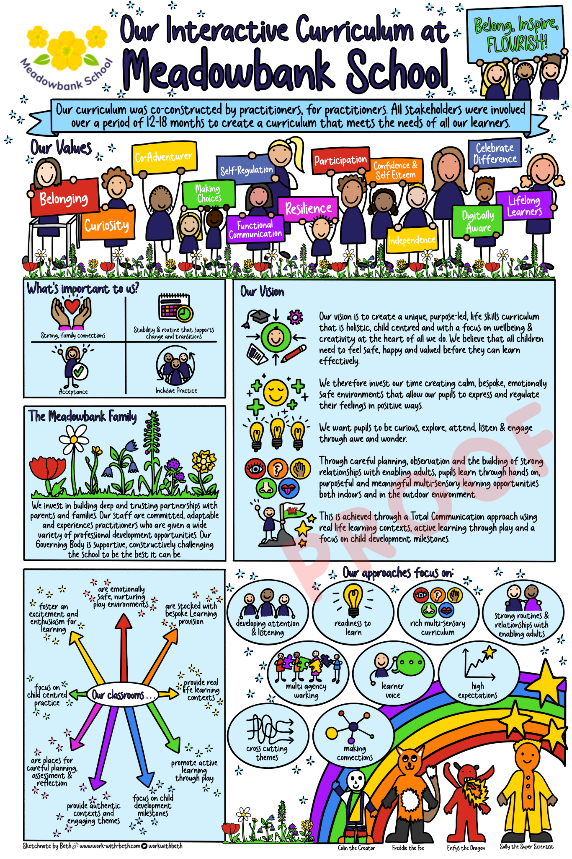

HEALTH & WELLBEING
Health and Wellbeing is at the heart of our curriculum and children’s skills are developed across all Areas of Learning Experience (AoLES). The building of strong, trusting relationships are key to pupils feeling safe, valued and ready to learn. Children learn about themselves, their relationships with other children and adults both within and beyond the family. They are encouraged to develop their self-esteem, personal beliefs, and moral values and are supported to develop an understanding that others have differing needs, abilities, and views.

Our curriculum supports the cultural identity of all children, helping children to recognise and gain a positive awareness of their own differences and other cultures. Positive attitudes are developed to enable children to become increasingly aware of, and appreciate the value of, the diversity of cultures and languages that exist in a multicultural Wales. Pupils become increasingly aware of the traditions and celebrations that are important aspects of the culture within Wales.

Pupils develop an awareness of their environment and learn about the diversity of people who live and work there. Positive attitudes of enjoying and caring for the environment are fostered. As self-identity develops, children begin to express their feelings and to empathise with others. Motivation and commitment to learning is encouraged, as children begin to understand their own potential and capabilities. Children are supported in becoming confident, healthy individuals and ambitious, capable learners.

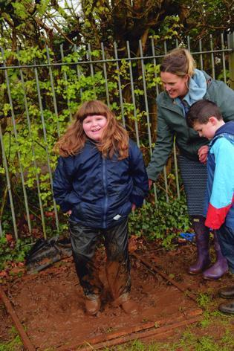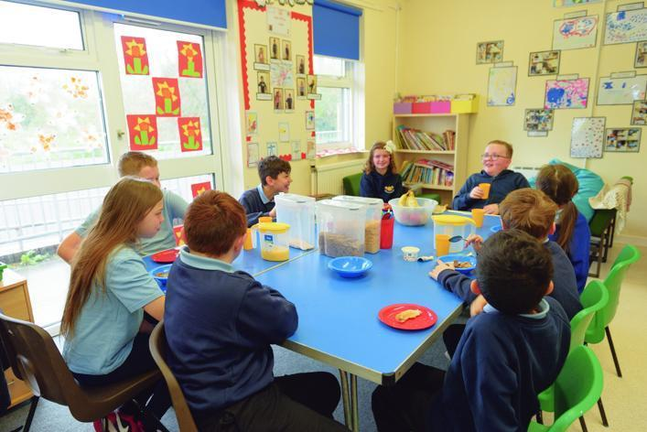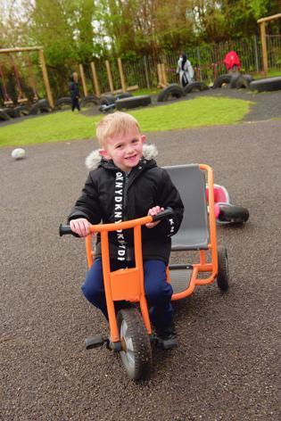

Children’s physical development, enthusiasm and energy for movement is continually promoted through helping them to use their bodies effectively, by encouraging spatial awareness, balance, control and coordination, and developing motor and manipulation skills. Pupils develop their gross and fine motor skills, physical control, mobility, and an awareness of space, using large and small equipment, across all Areas of Learning, indoors and outdoors. Children are encouraged to enjoy physical activity.

A developing sense of identity is linked closely to the children’s own self-image, self-esteem, and confidence. The children are introduced to the concepts of health, hygiene, safety, and the importance of diet, rest, sleep and exercise. Pupils are encouraged to join in whatever their abilities and will have the opportunity to develop skills in outdoor games and adventurous activities. Children in Year 5, and Year 6, have weekly swimming lessons for 2 terms.

CROSS-CURRICULAR SKILLS FRAMEWORK
Literacy, numeracy and digital competence are mandatory cross-curricular skills within Curriculum for Wales.

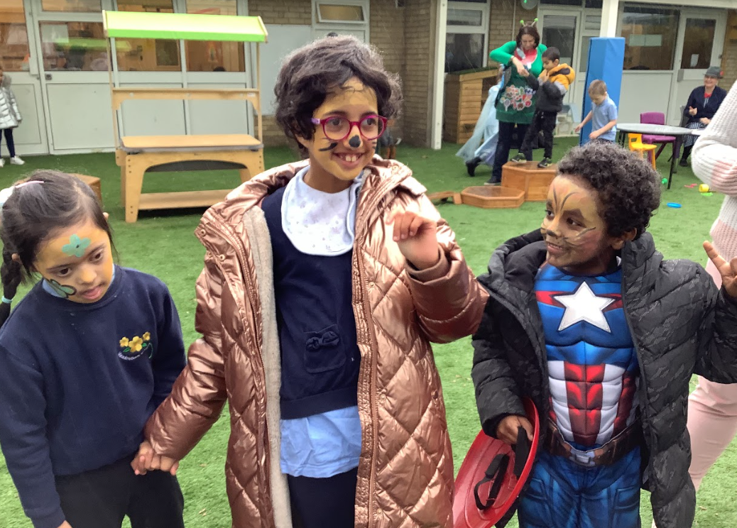

LANGUAGE, LITERACY AND COMMUNICATION SKILLS
Pupils are immersed in language experiences and activities. Their skills develop through talking, signing/communicating, attending and listening. They are encouraged to communicate their needs, feelings, and thoughts, retell experiences, and discuss individual and group play. Some children will communicate by means other than speech, such as using Makaton or photographs and symbols to express their needs, wants, thoughts and opinions. Children refer to their intentions by asking questions, voicing/expressing opinions and making choices through a variety of media and by building on previous experiences.

They are encouraged to listen and respond to others, to the variety of life experiences that their peers bring to the learning environment, and to a range of stimuli, including audio-visual material and ICT interactive software. Where appropriate, pupils have opportunities to choose and use reading materials and are given a wide range of opportunities to enjoy mark-making and writing experiences. They are helped to develop an awareness of Wales as a country with two languages.

English/literacy is developed through an integrated approach to speaking and listening, reading, and writing. Class Teachers, Speech and Language Therapists and Learning Support Assistants work together to help children in all aspects, including their social use and understanding of language.

A total communication approach is used to ensure that pupils have every opportunity available to communicate their needs, wants and thoughts to receptive staff. Targeted interventions are also used to develop a deeper understanding. These include Makaton to support speaking and understanding, Colourful Semantics to support and encourage spoken and written language, Cued Articulation to develop children’s phonological skills and Blanks Questions to support children’s understanding.

MATHEMATICS & NUMERACY

Pupils are encouraged to develop their skills, knowledge and understanding of mathematics through play activities, experience and a ‘hands on’ approach. They enjoy using and applying mathematical skills in real life contexts and through authentic experiences. They use a variety of ICT resources as tools for exploring number, colour and shapes as well as for obtaining real-life data and presenting their findings.

Pupils are supported to develop their use and understanding of mathematical language in context, through play, communication and song. Where possible, the children use appropriate mathematical language to explain their thinking, which supports the development of their reasoning. They develop a range of flexible methods using number, moving on to using more formal methods of working and recording when they are developmentally ready. Pupils are supported to use mathematical language through a Total Communication approach, with Makaton, symbols and photographs used to support both receptive and expressive communication.

The children explore, estimate, and solve real-life problems in both the indoor and outdoor environment. They develop their understanding of measure, investigate the properties of shape and space, and develop early ideas of position and movement through practical, physical experiences. They have authentic opportunities to sort, match, sequence and compare objects, explore and create simple patterns and relationships, and present their work in a variety of ways.

Pupils begin to explore their understanding of time through understanding the sequence of their day, taking part in routine, everyday activities and by reflecting on their past learning and experiences. Mathematics and numeracy teaching is tailored to meet individual needs so that each child is challenged and motivated to achieve success at their own level. Pupils are supported to develop their mathematical skills and knowledge across the curriculum, embedding their understanding in a variety of contexts.

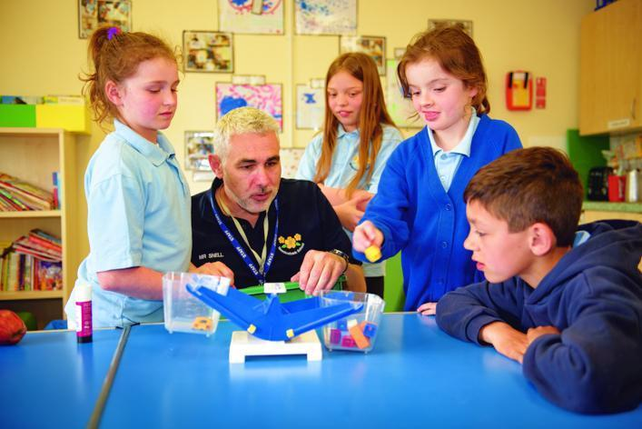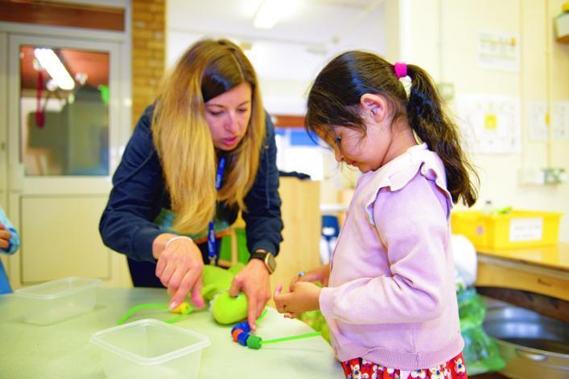

DIGITAL COMPETENCE

Digital competence is the set of skills, knowledge and attitudes that enable the confident, creative and critical use of technologies and systems. It is the skill set that enables a person to be a confident digital citizen, to interact and collaborate digitally, to produce work digitally, and to be confident in handling data and computational thinking (problem solving).

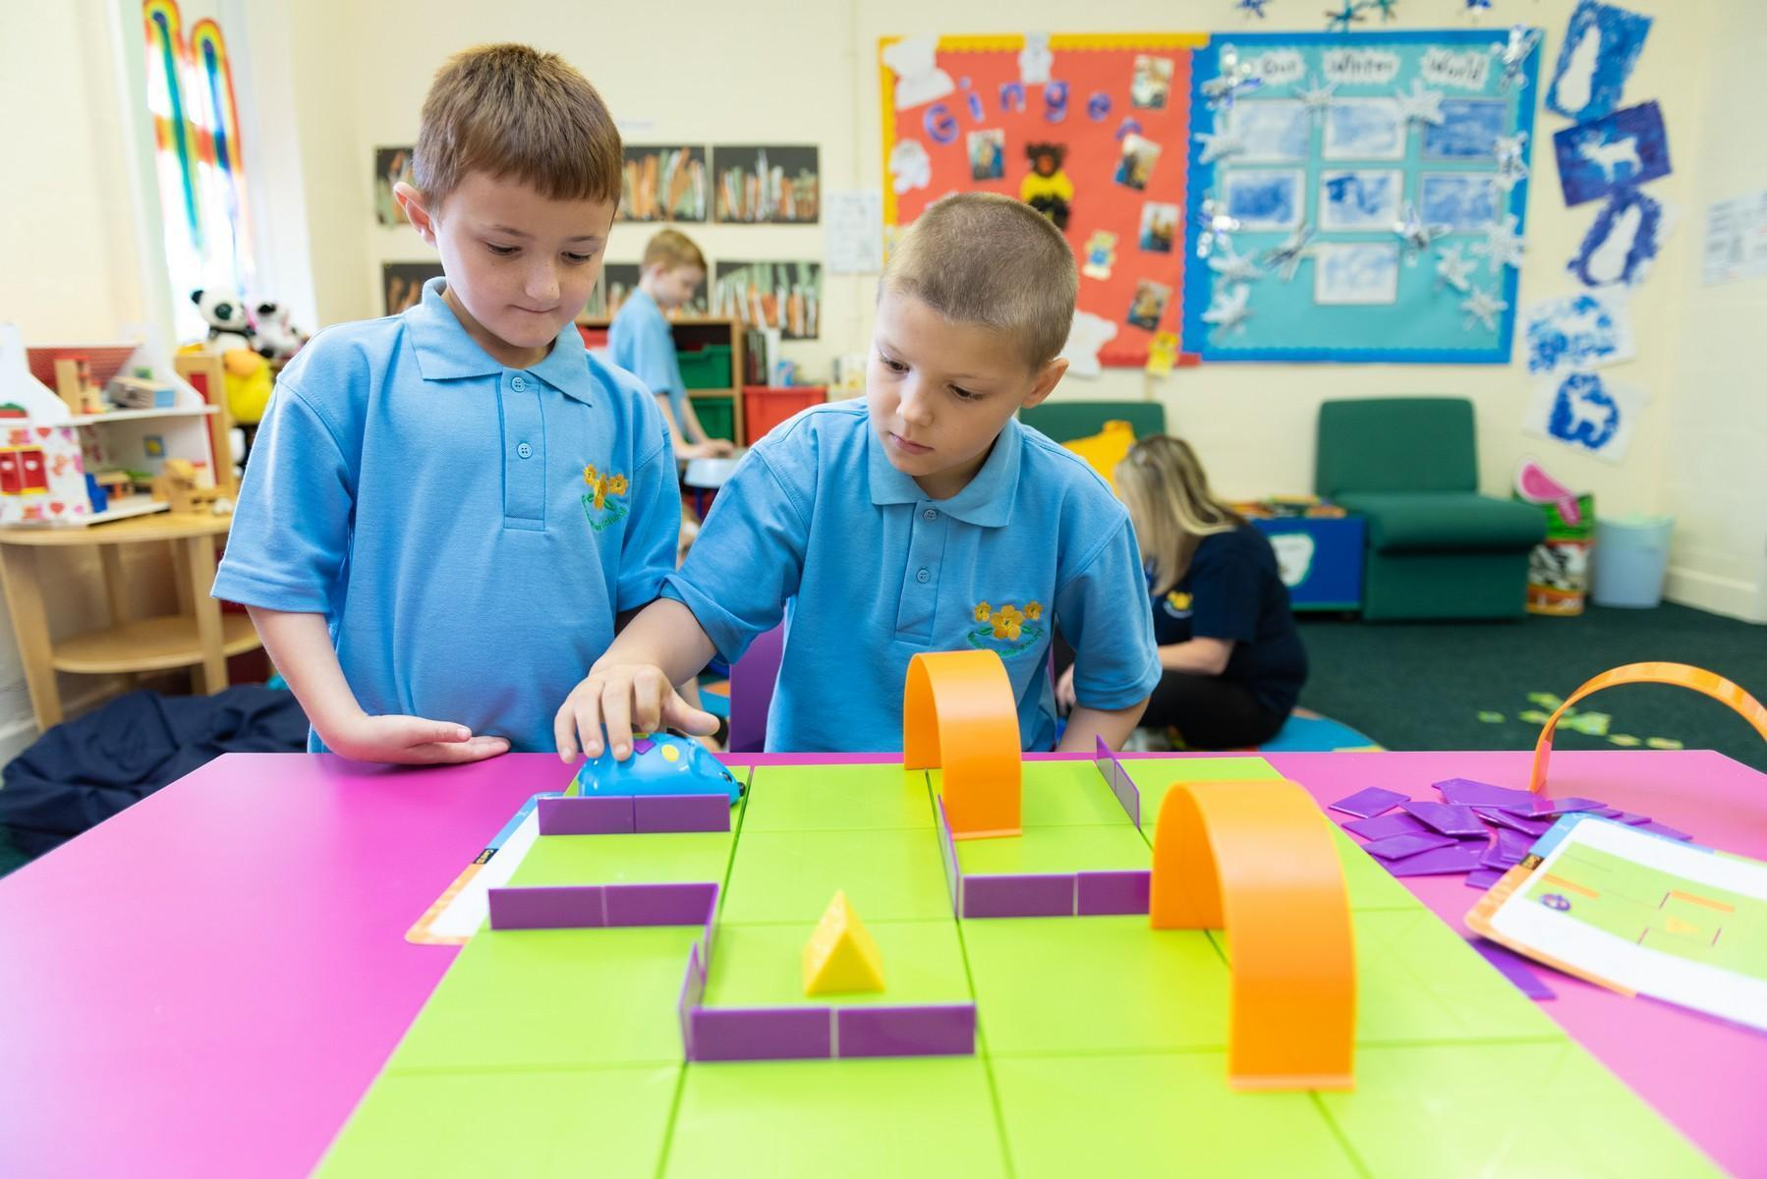

Digital competency is taught across the curriculum allowing pupils to apply their IT skills across a range of activities and curriculum areas. Each classroom is equipped with an interactive whiteboard & iPads. A wide range of hardware and software is available to support the curriculum and the school is networked so that teachers can share resources.

SCIENCE & TECHNOLOGY
Pupils are encouraged to be curious and to question the world around them. Pupils are given opportunities to explore and manipulate objects, to investigate how things work and to solve problems in their everyday environment. Pupils are supported to explore the properties of objects and materials, exploring how they are used and how things change.

Pupils have access to our edible garden which allows them to learn about the environment and living things. Pupils are supported to watch how plants grow, by planting seeds and tending to them, seeing them grow into fruits and vegetables that can be enjoyed. Pupils learn about the seasons and the sequence of events throughout the year. Using all of their senses, the children are encouraged to enjoy learning by exploration, enquiry, experimentation, asking questions and trying to find answers.

Through curiosity, pupils can learn about sound, light and energy. Pupils have access to a range of materials that can support their exploration and understanding of these natural elements of our world. Where possible, pupils can then use their understanding to begin to make predictions and collect information, presenting it in a variety of ways.
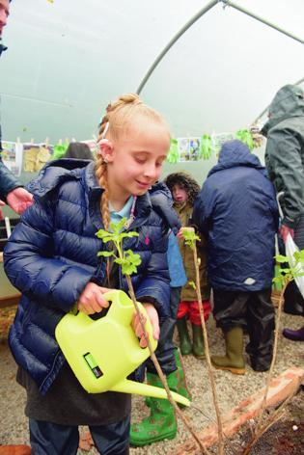
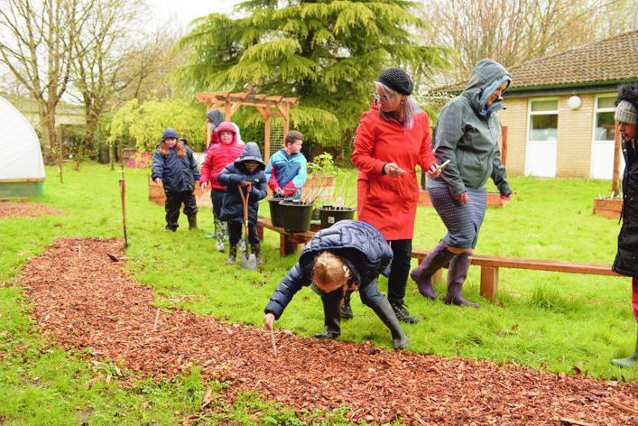
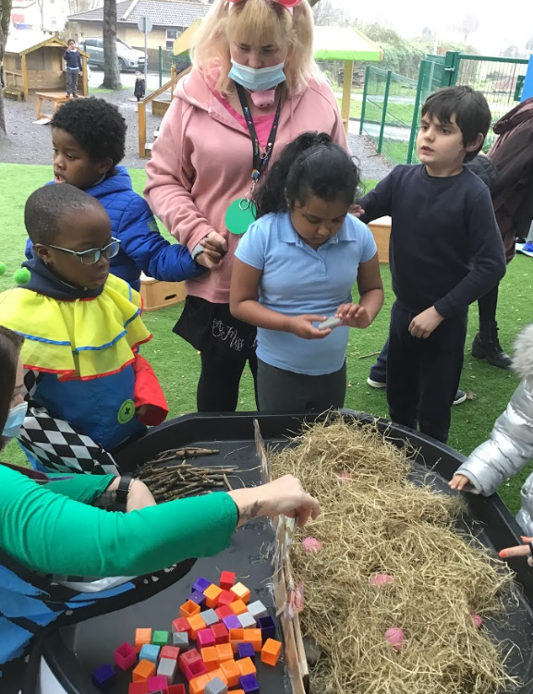

HUMANITIES
Pupils experience the familiar world through enquiry, investigating the indoor and outdoor environment in a safe and systematic way. They are given experiences that help them to increase their curiosity about the world around them and help them to begin to understand past events, people and places around them. Through visits to the community, pupils are supported in developing their understanding of the natural and built world, becoming more familiar with their local environment and wider world.

The children learn to demonstrate care, responsibility, concern and respect for all living things and the environment. They develop and communicate using an increasing range of appropriate vocabulary. They learn to express their own ideas, opinions and feelings with imagination, creativity, and sensitivity, whilst developing an understanding of the feelings of others. The children are supported to begin to understand their own identity, both as individuals and as part of a wider community.

The school is not affiliated to any faith, but we do value the contribution faith makes in developing caring, tolerant, and respectful young people. Understanding of world religions is encouraged through the exploration of a variety of festivals from faiths around the world. Staff role model and encourage good values throughout the school day, encouraging pupils to become the best version of themselves.

EXPRESSIVE ARTS
Children are continually developing their imagination and creativity across the curriculum. Their natural curiosity and disposition to learn is encouraged by everyday sensory experiences, both indoors and outdoors. Children engage in creative, imaginative, and expressive activities in disciplines such as Art, Craft, Design, Music, Drama, Dance and Movement. Children experience a wide range of stimuli, develop their ability to communicate and express their creative ideas, and reflect on their work.

Our pupils are given opportunities to embrace live music through visits to the school and external trips. The school has supported several student placements in conjunction with local universities which has afforded us access to mu
sic therapy. This proves to be a successful intervention, when possible, for our pupils who love using music as a means to express themselves.
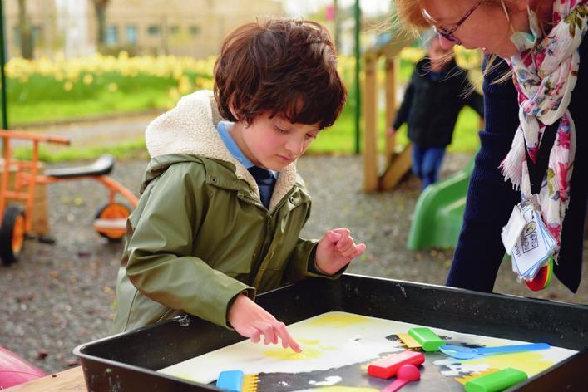
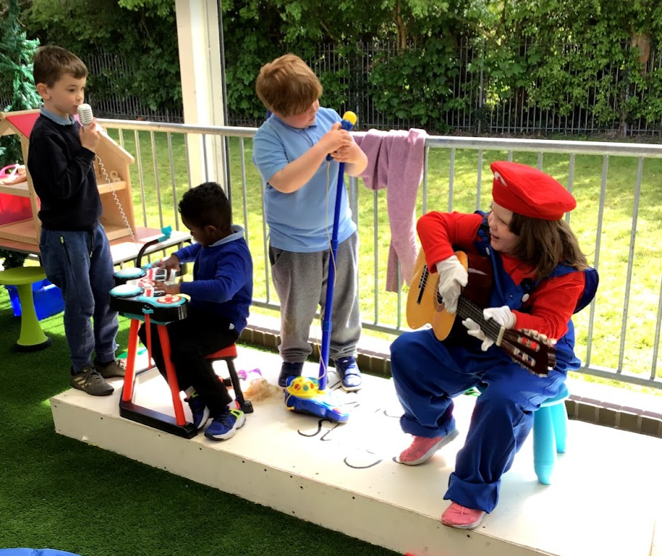

WELSH
Welsh is not taught to pupils as a specific subject at the school. For children with severe speech and language impairment, the development of their competence and confidence in the first language is considered the primary need. The additional time is used for extra language and communication activities. The school recognises the importance of creating a Welsh ethos within the school. It is generally accepted that an effective means of introducing Welsh is by using it in incidental situations throughout the day. The aim is to ensure that pupils achieve regular success through a broad and varied balance of skills and experiences. Curriculum Cymraeg encompasses not only Welsh as a second language, but also all those aspects of school life, which promotes pupils’ understanding of Welshness including all other curriculum areas.

THE CURRICULUM AND ASSESSMENT FRAMEWORK
Pupil progress is carefully monitored throughout their time at the school. Children are assessed each term, using a range of assessments, to establish where they are in their learning and to review the progress that they have made. The assessment results provide information for class teachers that enable them to plan for individual pupil’s learning. Pupil progress is tracked using a range of assessment measures. These results inform the planning of learning goals for each child as well as providing evidence of a pupil’s progress and they are used for setting whole school targets.
Assessment results are shared regularly with parents at termly Pupil Progress Meetings as well as at IDP meetings.

INDIVIDUAL EDUCATION PLANS
An Individual Education Plan (IEP) is written each term for every pupil. Targets are set for each child, and these are worked on during the following term. Parents are invited into school once a term to review the child’s Individual Education Plan with the Class Teacher & Learning Support Assistants.

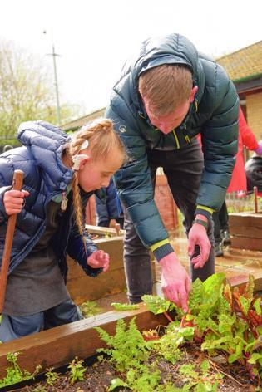
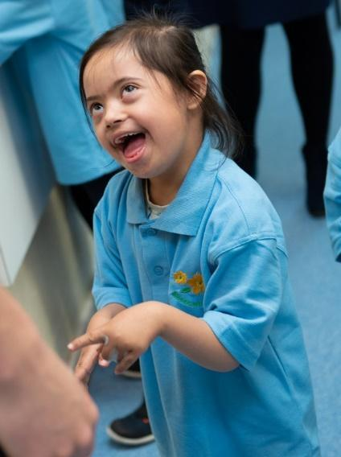
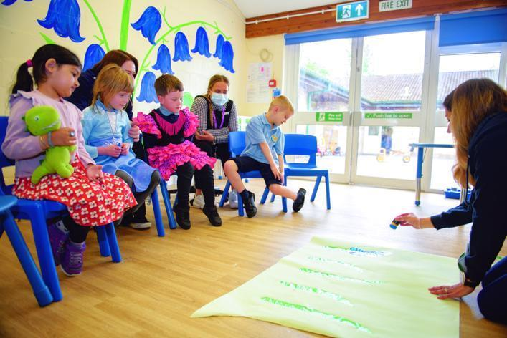

A number of specialised programmes have been developed and utilised at the school to meet the needs of pupils with a range of complex learning needs. Some of the areas of work include:

- Attention and listening skills
- Visual perception skills
- Vocabulary building
- Sentence building using Colourful Semantics
- Signing - Makaton
- Development of play skills
- Intensive Interaction to support the development of social communication skills.

Parental & Community Engagement

School PTAs organise various events throughout the year with all funds raised being used to enhance the school experience for all pupils. For many years the school had an active PTA called ‘Meadowbank Mates’. In recent years, with the changing remit and the growth of the school we have struggled to find parents who would like to continue with this important work.

Are you interested in being part of the PTA, Please speak to Mrs Hardy by ringing the school office. We would love to have as many parents involved as possible to continue to raise funds for the school.

PARENTAL ENGAGEMENT
It was pleasing to be able to welcome parents back into school this year for a number of events. These included face-to-face Parents Evenings, Annual Review Meetings and IDP Meetings. It was clear that the strong relationships forged with parents during lockdown and the range of communication systems the school has in place for parental engagement worked very well.

COMMUNITY LINKS
Meadowbank has strong links with the local PCSO. Every year pupils have access to ‘people who help us’ sessions with our local community police officer, as well as visits and assemblies from the local fire brigade. We have also welcomed visits this year from Grow Cardiff, Trees for Cities, Cardiff Rugby Community, Alis Huws Harpist, Live Music Now Cymru, Father Christmas and Penarth Chamber Music Festival.

Multi Agency Support

SCHOOL DOCTOR
Dr Kate Skone is the school’s community paediatrician. She liaises with the school several times each term to provide a holistic understanding of pupil needs. She may be invited to contribute information to pupils' Individual Development Plan meetings, especially where pupils have medical needs. It is hoped to start clinics for parents / pupils at Meadowbank (rather than St David’s Hospital) in the new academic year.

SCHOOL NURSE
Anna Nichol, the generic school nurse, is based at the local Riverside clinic. She may be involved in school medicals, weighing and measuring pupil’s height and any other health checks at the request of the school doctor. She also supports the flu immunisation programme.

SPEECH & LANGUAGE THERAPY
The Speech and Language Therapists at the school will discuss any referrals with parents and gain their consent prior to any referral.

OCCUPATIONAL THERAPY
The Occupational Therapy team work closely with the school to develop opportunities in school which help our children regulate and become ready for learning. Together we have created sensory/motor opportunities to build skills which enable our children to become more independent. The occupational therapy service is available to deliver training to teachers and parents. Occupational Therapy can be accessed directly by parents using the ‘Request for Assistance’ process. School can also make requests for Occupational Therapy input with a parent's consent.

